External Coupling

📌 Definition:
# Source: AI Source: Provided by: [Data Path: Persons Table -> ID Column: 1, Name_En Column: Motasem Essam] -> From: [Chatgpt (GPT‑5 Mini)] on [12/9/2025]
External Coupling occurs when classes/modules depend on external systems or libraries, such as files, databases, hardware, or third-party APIs.

🧠 Simple idea:
# Source: AI Source: Provided by: [Data Path: Persons Table -> ID Column: 1, Name_En Column: Motasem Essam] -> From: [Chatgpt (GPT‑5 Mini)] on [12/9/2025]
“Modules rely on something outside the program” ⚠️

🔍 Key characteristics:
# Source: AI Source: Provided by: [Data Path: Persons Table -> ID Column: 1, Name_En Column: Motasem Essam] -> From: [Chatgpt (GPT‑5 Mini)] on [12/9/2025]
- Dependency is on external resources rather than other classes internally
- ❌ Changes in the external system can break the module
- ❌ Reduces portability
- ⚙️ Can be mitigated with abstraction layers

📊 Example of External Coupling (Bad Practice):
# Source: AI Source: Provided by: [Data Path: Persons Table -> ID Column: 1, Name_En Column: Motasem Essam] -> From: [Chatgpt (GPT‑5 Mini)] on [12/9/2025]
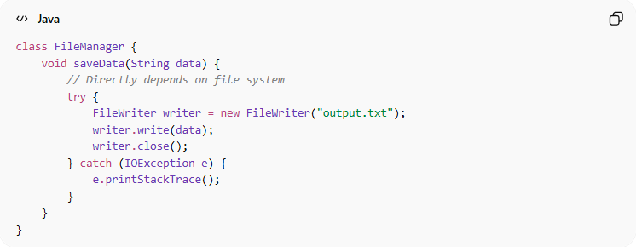

class FileManager {
void saveData(String data) {
// Directly depends on file system
try {
FileWriter writer = new FileWriter("output.txt");
writer.write(data);
writer.close();
} catch (IOException e) {
e.printStackTrace();
}
}
}
- ✅ FileManager is directly coupled to the file system
- ✅ Any change in file structure or storage system may break this code

🛡️ Avoiding External Coupling Example:
# Source: AI Source: Provided by: [Data Path: Persons Table -> ID Column: 1, Name_En Column: Motasem Essam] -> From: [Chatgpt (GPT‑5 Mini)] on [12/9/2025]
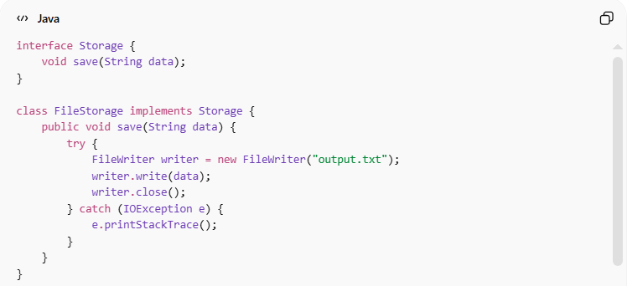
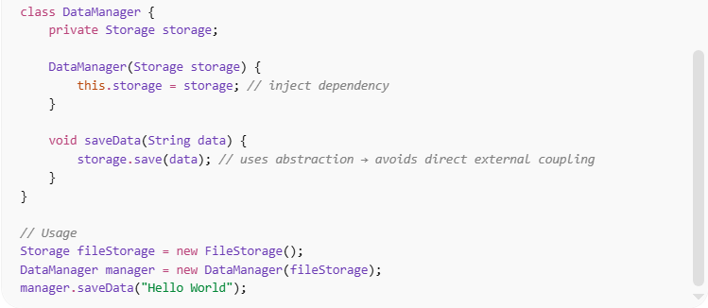
interface Storage {
void save(String data);
}

class FileStorage implements Storage {
public void save(String data) {
try {
FileWriter writer = new FileWriter("output.txt");
writer.write(data);
writer.close();
} catch (IOException e) {
e.printStackTrace();
}
}
}

class DataManager {
private Storage storage;

DataManager(Storage storage) {
this.storage = storage; // inject dependency
}

void saveData(String data) {
storage.save(data); // uses abstraction → avoids direct external coupling
}
}

// Usage
Storage fileStorage = new FileStorage();
DataManager manager = new DataManager(fileStorage);
manager.saveData("Hello World");
✅ Key improvements:
- DataManager does not directly depend on the file system
- Can swap FileStorage with DatabaseStorage or other implementations
- Improves modularity, flexibility, and testability

⚙️ Best Practice:
# Source: AI Source: Provided by: [Data Path: Persons Table -> ID Column: 1, Name_En Column: Motasem Essam] -> From: [Chatgpt (GPT‑5 Mini)] on [12/9/2025]
- Depend on abstractions/interfaces instead of concrete external systems
- Apply dependency injection
- Encapsulate external system access inside dedicated classes
- Makes code easier to maintain, test, and extend

